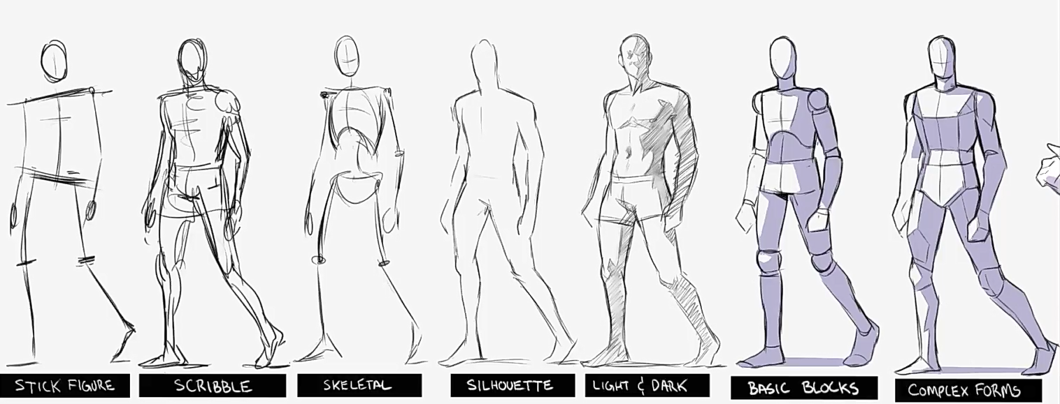

**1. Stick figure :**

Stick figure is great because it gives us the angle for shoulders & pelvis. There's not much form going on, no to much details, just tilt of the body which help to know how much a body is leaning sideways.

It gives us the good sense of gesture and pose.

**2. Scribble figure :**

Its the most innate way to draw. Lot of the times artist use this way to draw underline structure of the figure. It is the way to figuring out actual form/pose of the figure by first scribbling the figure. It is the traditional way. That's the value of being loose.

It gives a nice framework to draw the final form. Scribbling are great way to draw from imagination. If you want to learn to draw from imagination, scribbling is the perfect way to do that, because you are not too concern about how it looks, you just worry about getting information out of your brain onto the page.

**3. Skeletal figure :**

This is sort of like stick figure but with a little bit of information about rib cage & pelvis that helps with the actual mass of body and also helps in figuring out the twist and turn of rib cage & pelvis.

**4. Silhouette figure :**

Author : I also prefer not to work inside-out, meaning you might have seen the classical artists where they draw the masses and forms and sort of adds the muscles on the top and then sort of build up.

I prefer to start from out silhouette because the value of drawing in silhouettes and shapes because you are really in the control of what will be the final form. It is lot easier for me to go and change any part of the body if i want to.

The drawback is that, by drawing in shape, we're loosing a lot of the form information.

**5. Basic building blocks :**

This one is really valuable for showing 3D volumes, showing how things fit in perspective.

But the drawback is to them, they can be little to rigid. You are less inclined to draw according to line of action, simplify your shape and explore different shape designs.

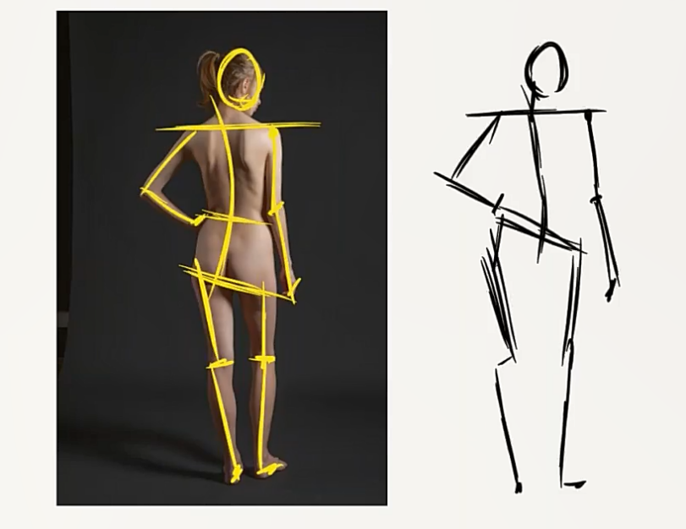 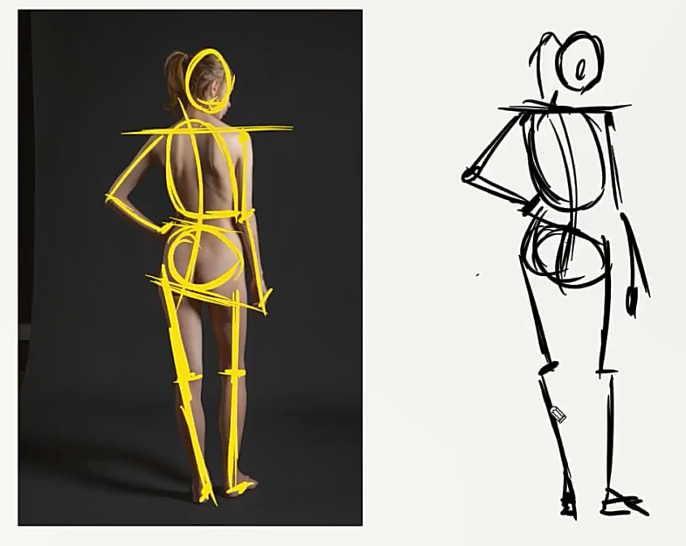

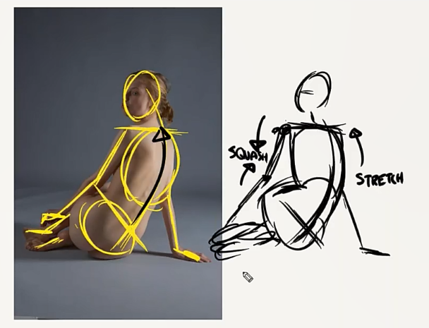 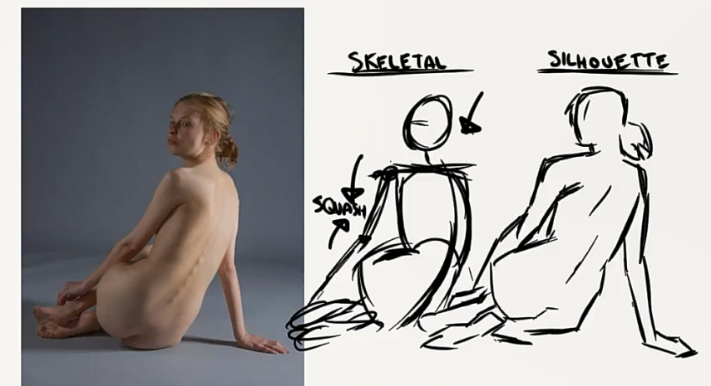

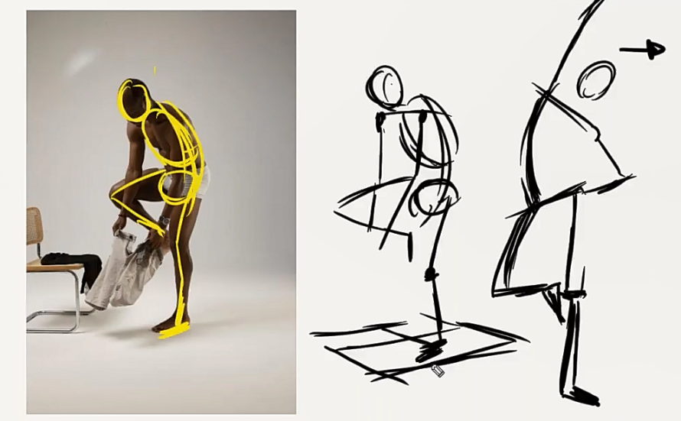

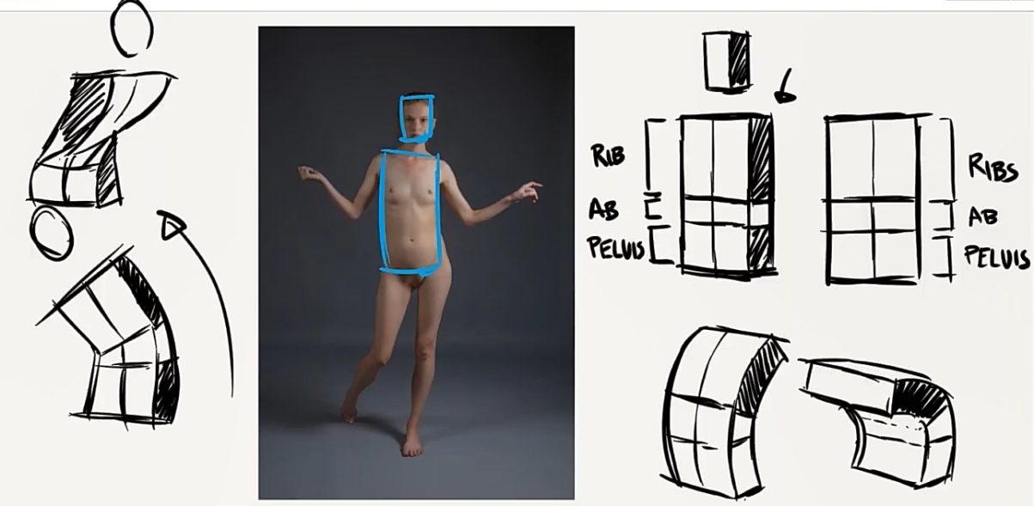

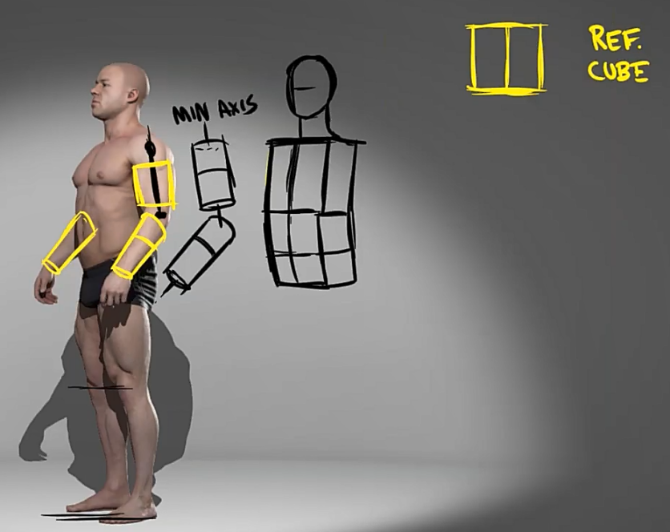 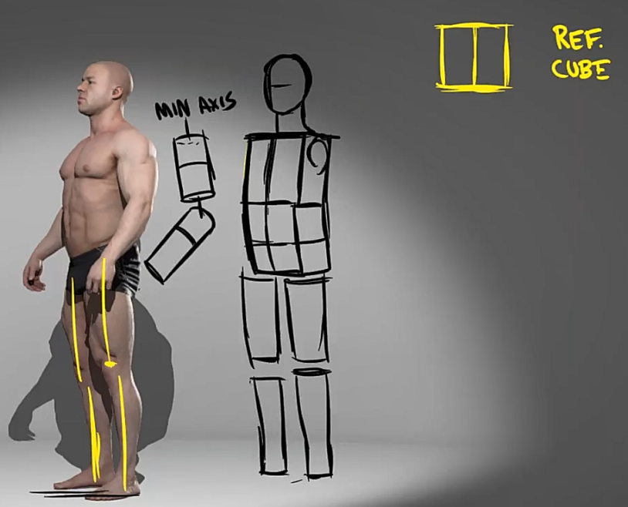

Ques : Which one do you prefer to use ?

Ans : It's like all of the hybrid combined into one. so depending on the pose, say pose have lots of twisting to it, I'll probably use little bit more of these building blocks Because it will give me more information about how the pose is turned in 3D space.

A lots of times when i am animating, I'll just draw in silhouette because these building blocks is already sort of in my mind so i am not too concern about sort reminding myself what those forms are doing.

Like i can look at the silhouette of an arm and know that it's essentially a cylinder going back in space. So that comes with time.

Part of our homework assignment this week is gonna be, drawing the figure with these different versions.

**Balance & Maintaining the center of gravity :**

So in order to keep the figure balance, we're gonna see that whenever we have a pelvic tilt, the shoulder's are counter balance that. The body maintains it's upright position, keeping that center of gravity on the floor.

There are times when you want your figure to be out of balance if the figure is jumping, running But when standing up right, then there going to be balancing it out. You're gonna notice that one of the legs, lots of times in casual poses, will take on more weight then the other.

Draw poses where body is out of balance, this will help you figure out how the body is tilting and how body naturally compensate for the any sort of disturbances.

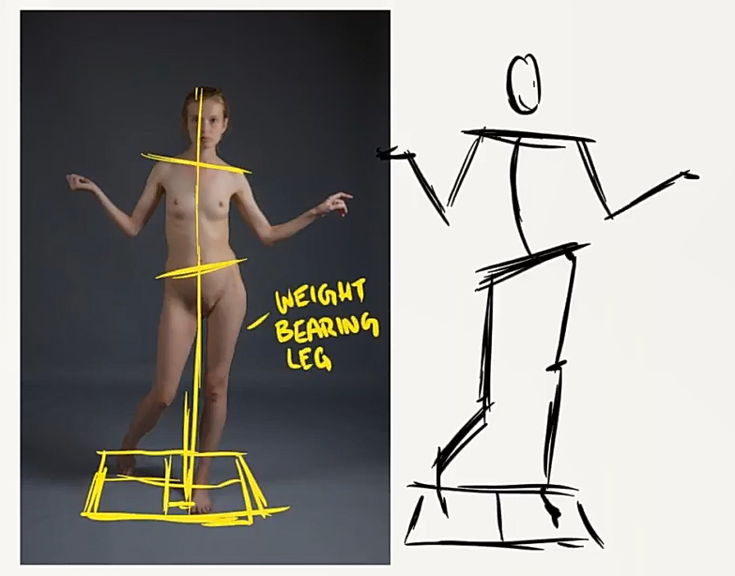

**Draw cylinders :**

start by drawing major body parts like arms, legs, necks and cylinders to get the sense of perspective and forms

Cylinder rotation :

as we start to rotate the cylinder towards us, 2 things are gonna happen,

1. we're gonna decrease the length of that cylinder

2. How circular that ellipse is gonna look

the more circular the ellipse of a circle is, the less we are gonna see of that ellipse

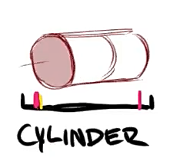 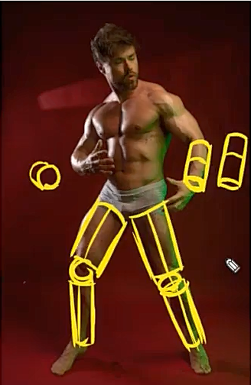

**Move from cylinders to more accurate shapes :**

We don't have to keep everything just as a cylinder, because our body isn't clearly full of cylinders.

First practice drawing arms-legs in cylinders and after that move onto more advance and accurate form shapes.

like a lower leg would be drawn like this, you can also sculpture it to make it look more realistic :

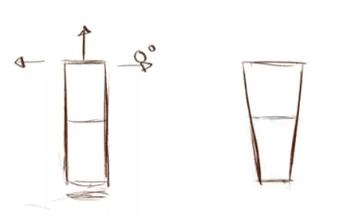 | 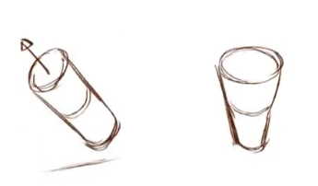 | 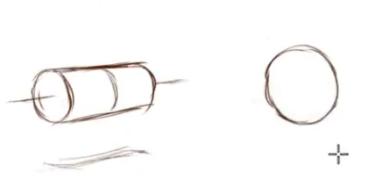 |

like a forearm would be drawn from cylinder like this :

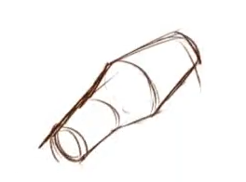

**Move from blocky shapes to more accurate shapes :**

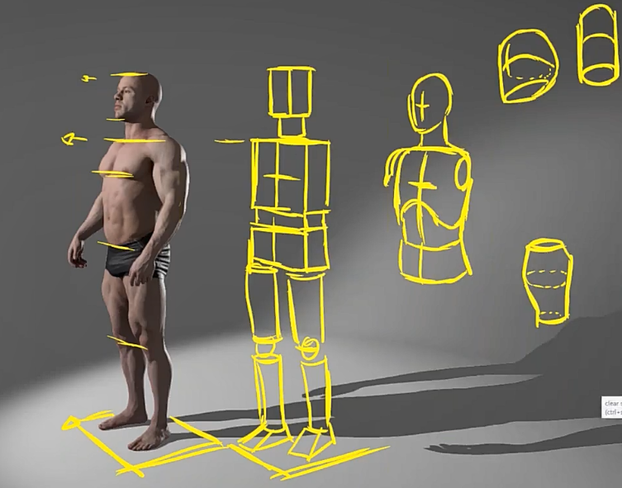 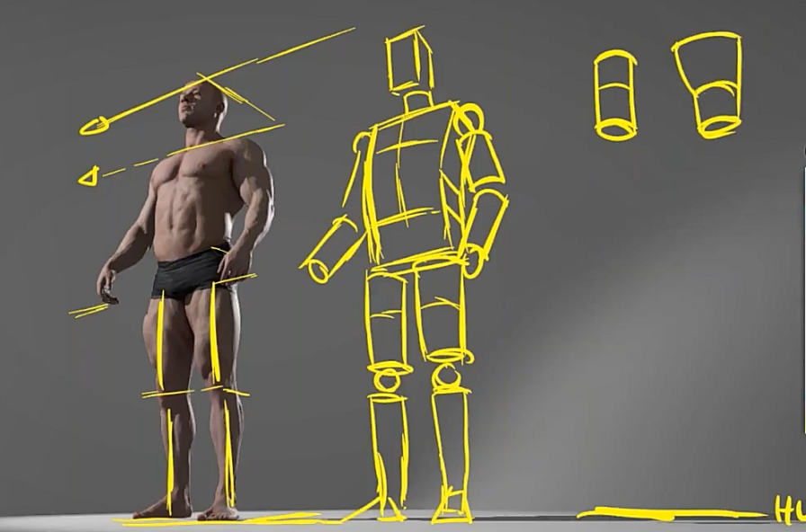

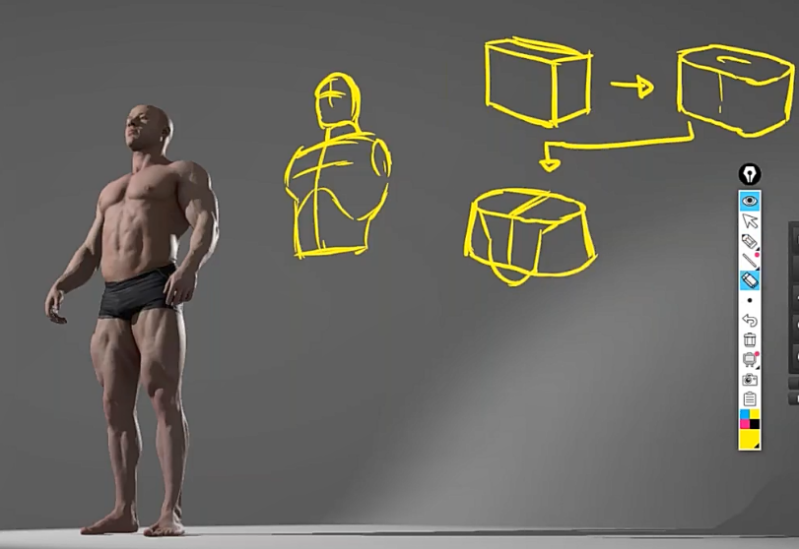 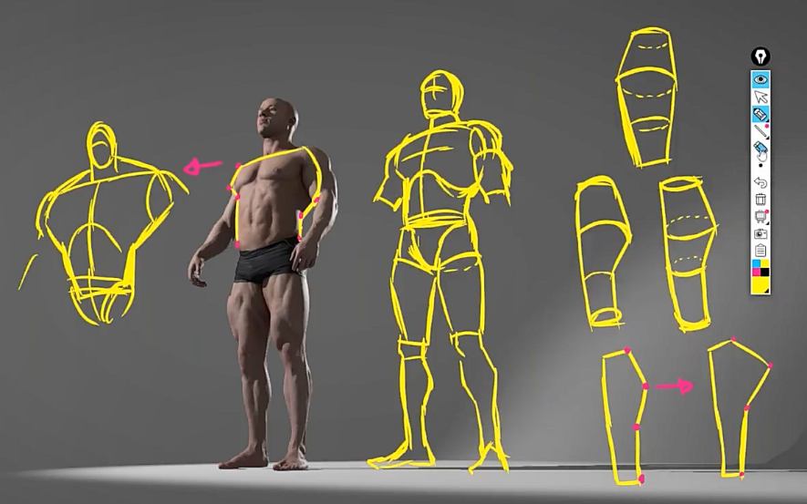

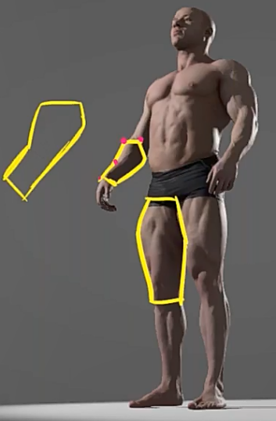 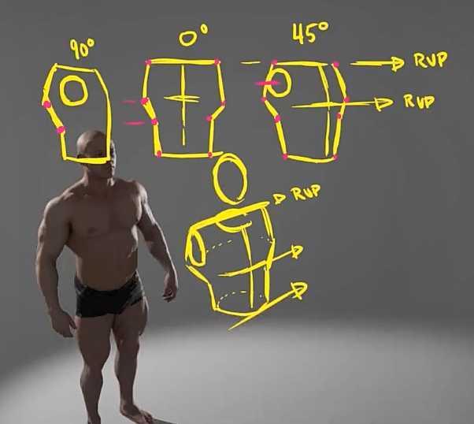

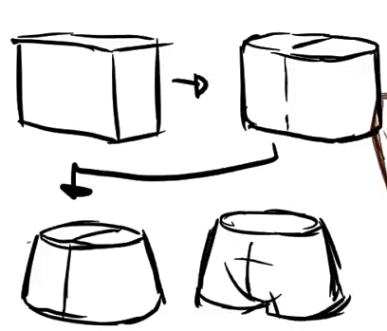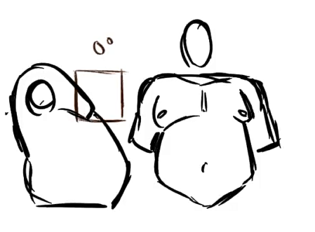

**Scribble & Silhouette are gonna be very important later on down the road.**

another things you can do is loosely sketching the figure out with silhouette. this helps drawing the figure faster for animation.

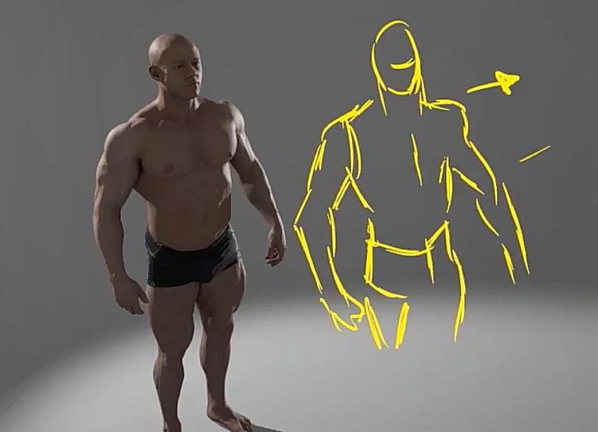

Some artists make the shapes way sharper instead of drawing the shape in curves to make the figure more accurate but it depends on the artists how they draw figure :

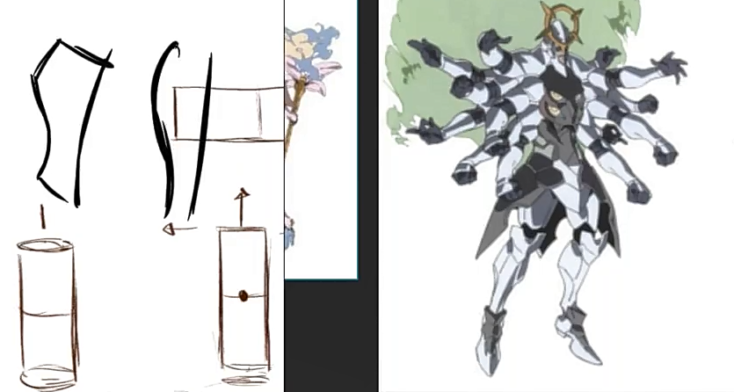

**Do turn around of the figures.**

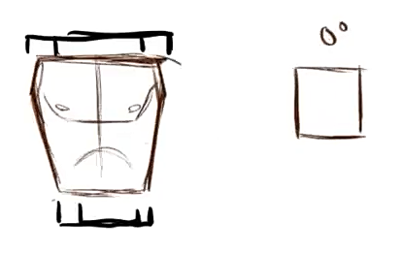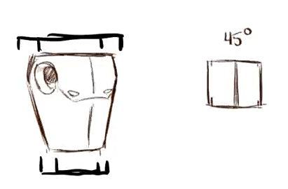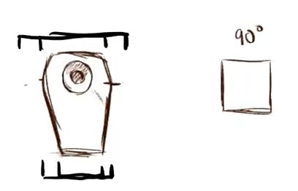

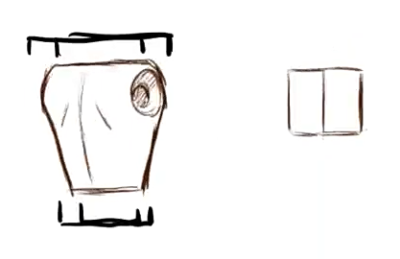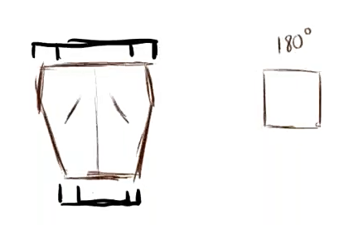

**Proportions :**

